阅读技巧--细节理解题、词义猜测题
细节理解题
1.题型特点
这类题在阅读理解中所占比例较大。它常常针对文章中的事实和细节进行提问,即针对(w)h-问题,如用when,where,why,how,who,which,what等进行提问,目的在于测试学生对说明文章中心思想的支撑事实和细节的理解能力。
2.细节理解题主要的设问方式
①Which of the following is true/not true?
②Which of the following is mentioned/not mentioned in the passage?
③Which of the following statements is true according to this passage?
④Which of the following best describes...?
⑤Which of the following shows/gives the right relationship /position of...?
⑥When/Where/Why/Who/What/How...?
3.细节理解题的解题技巧
所谓“事实细节”,是指在阅读理解的短文中客观存在的事实。细节理解题的答案一般都可以在原文中找到。一般来说,应在短文中找出相关信息的位置,确定试题测试的考点。当然,有的试题还得对原文所提供的事实进行一定的分析比较,才能做出正确的选择。
(1)搜寻直接答案的阅读技巧
先阅读所给的问题,判断其是否适合采用直接搜寻的阅读方法。如果所提问题是文章中出现的内容(即直接性答案),就可直接搜寻答案。
(2)搜寻间接答案的阅读技巧
①阅读文章所给的问题,判断哪些题目可以依靠通读来解决。比如概括文章主题,给无标题文章选标题,指出作者的观点、意图等的题目就需要依靠通读来解决。
②用较短的时间大体上浏览一下阅读材料,注意文章有可能涉及什么内容,属于什么体裁,以及文章安排的大体轮廓等。
③从头到尾阅读一遍。一般来说,第一段或前几句包含作者的基本思想和下文的发展线索,它是全文展开的基础,为下文发展搭建了理论框架。认真阅读第一段或文章的前几句,尽量抓住其中的主要情节和论点,把握全文发展的脉络。
④有些细节题容易出错主要有几种情况:
a.干扰项多。类似的内容多而杂,需要从中找出准确答案。例如:短文同时出现多个朋友,过去现在的十几种爱好,细节题考某人过去的爱好,需要在多而杂的内容中,带上问题,逐一去寻找,比对,找到正确选项。
b.迷惑性强。例:文中出现总金牌数,问题问的是奥运金牌数,粗心的考生易错选总金牌数。这类题要看清关键信息。
词义猜测题

题型特点
这类题型旨在考查学生利用上下文对词、词组以及句子的辨别能力。利用上下文猜测词义是阅读理解的基本技巧之一,也是我们学习词汇的主要方法。在阅读过程中,有些同学一遇到生僻词语就查词典,这是不可取的。一遇到生僻词语就查阅词典不但会使我们养成依赖词典的习惯,而且还会影响阅读速度。我们阅读汉语文章时遇到不认识的词语是否都查词典呢?答案是否定的。可是我们是如何理解它们的呢?利用上下文提示猜测词义就是诀窍。
词义猜测题的类型主要有三种:熟词新义要求学生在某一特定的语言环境中推断某一多义词的正确意思;生词释义要求学生根据范围较小的上下文推断出词义;难句释义要求学生根据范围稍大的上下文推断句意。
2.词义猜测题主要的设问方式
①What’s the meaning of the underlined word/phrase...in Chinese?
②The underlined word...refers to/probably means...
③The underlined word...could be replaced by...
④What is the meaning of...
⑤Which of the following words can take the place of the word...?
3.词义猜测题的解题技巧
(1)通过因果关系猜测词义
通过因果关系猜词,首先是找出生词所在部分与上下文之间的逻辑关系,然后才能猜词义。有时文章借助关联词(如because,as,since,for,so,thus,as a result,of course,therefore等)表示因果关系。
例You shouldn’t have blamed him for that,for it wasn’t his fault.
解析 通过for引出的句子所表示的原因(那不是他的错),可猜出blame的词义是“责备”。
(2)通过同义词和同义关系猜测词义
在文章中,有时作者为避免重复,或为了表达同一事物的不同种类,使用同义词或近义词。在这种情况下,我们就可以利用同义词、近义词的关系由熟悉的词语推测不熟悉词语的含义。
通过同义词猜词,一是要看由and或or连接的同义词词组,如happy and gay,即使我们不认识gay这个词,也可以知道它是“愉快”的意思;二是看在进一步解释的过程中使用的同义词。
例 Man has known something about the planets Venus,Mars,and Jupiter with the help of spaceships.
解析 此句中的Venus(金星),Mars(火星),Jupiter(木星)均为生词,但只要知道planets就可猜出这几个词都属于“行星”这一领域。
(3)通过反义词和反义关系猜测词义
有时作者为了说明相反的两件事或人,使用了一些反义词或表示反义关系的词语来进行对比,我们可以利用已知单词推测未知单词的词义。
通过反义词猜词,一是看表转折关系的连词或副词,如but,while,however等;二是看与not搭配的或表示否定意义的词语。
例 He is so homely,not at all as handsome as his brother.
解析 根据“not at all as handsome...”我们不难推测出homely是“不英俊,不漂亮”的意思。
(4)通过构词法猜测词义
在阅读文章时,我们总会遇上一些生词,有时很难根据上下文来推断其词义,而它们对文章的理解又有着举足轻重的作用。此时,如掌握了一些常用的词根、前缀、后缀等构词法知识,这些问题便不难解决了。
(5)通过定义或释义关系猜测词义
定义或解释形式多样,常由is,that is(to say),in other words,call,mean,be considered to be,refer to,be called,be known as,define,represent等词汇或破折号来表示。作者为了更好地表达思想,在文章中对一些重要的概念、难懂的术语或词汇等进行解释。这些解释提供的信息具有明确的针对性,利用它们猜词义比较容易。如果生词是句子或段落所解释的定义,理解句子或段落本身就是推断词义。
例 But sometimes,no rain falls for a long,long time.Then there is a dry period,or drought.
解析 从drought所在的句子我们得知很久不下雨,于是便有一段干旱的时期,即drought,由此可见drought的意思是“久旱,旱灾”。而a dry period和drought是同义词。这种同义或释义关系常由is,or,that is,in other words,be called或破折号等来表示。
(6)通过举例来猜测词义
恰当的举例能够提供猜测生词的重要线索。
例 Bananas,oranges,pineapples,coconuts and some other kinds of fruit grow in warm areas.
解析 pineapples和coconuts是生词,我们可以从这两个词在句中所处的位置来判断它们大概的意思。从句中不难看出pineapples,coconuts和bananas,oranges是同类关系,同属fruit类,因此它们是两样水果,准确地说,是菠萝和椰子。
(7)通过描述猜测词义
描述即作者为帮助读者更深刻更感性地了解某人或某物而对该人或该物作出的描写。
例 The penguin is a kind of seabird living in the South Pole.It is fat and walks in a funny way.Although it cannot fly,it can swim in the icy water to catch the fish.
解析 从例句的描述中可以得知penguin是一种生活在南极的鸟类,即企鹅。后面更详尽地描述了该鸟类的生活习性。
(8)根据上下文猜测词义
①有些单词并不能直接猜测出其词义,但可以根据上下文的提示猜测出其词义。
例 One of the things I always believe is that no matter how bad something is,you can take something positive out of it.
It wasn’t until a few weeks after September 11 that I began to see that perhaps some good did come from this tragedy.
The word“positive”in the passage probably means .
A.terrible B.bad C.good D .real
解析 根据上文“我一直认为不管世间的事物有多么糟,你还是能发现它积极的一面。”因此答案是C。
②在句子或段落中,若事物、现象之间构成因果关系,我们可以根据这种逻辑关系推知生词词义。
例 If he thinks he can invite me out,he is all wet.I don’t like to be with him.
The underlined phrase“all wet”means .
A.drunk B.sweating C.happy D.wrong
解析 根据下文“我不喜欢跟他在一起”可知,他如果认为能约我出去,那就“错了”。因此D是正确答案。
(9)根据生活常识猜测词义
有时,我们利用自己的生活常识,便可知道生词的含义。
例 A deaf-and-dumb guy went into a hardware store to ask for some nails.
解析 从句子意思可知他想买钉子,那么卖钉子的商店无疑是五金店。
(10)利用单词的发音进行推测
英语中有些单词来自汉语,与汉语的发音有些相似,另外也有一些单词译成汉语时采用音译,如:sofa(沙发),coffee(咖啡),typhoon(台风),aspirin(阿司匹林),nylon(尼龙)等。因此,利用单词的发音也是一种猜测的手段。
例 The Olympic Games began in the 5th century BC.
One day it was revealed that Mrs Morel had cancer and was beyond any help except that of morphine.
解析 上面这两个句子中画线的两个词,只要我们能准确发音,就能知道它们的意思分别是“奥林匹克”和“吗啡”。

专题训练
一
Experiencing China
Mike, Canada
I spent three months with my host family(接待家庭)in China. It was a lifetime experience. I was able to experience Chinese living and culture, from basic Tai Chi to Beijing Opera. I even visited a famous traditional Chinese medicine hospital. Now I have a better understanding of Chinese culture.

Joanna, Australia
I stayed with my host family for five months. My host mother is a Chinese teacher and she is really warm-hearted. With her help, my Chinese has improved a lot. And I have got used to a new culture. My favorite part of the experience was sharing my feelings in China with her.

Bill, America
My host mother is a wonderful cook! She makes me all kinds of traditional Chinese dishes. They are tasty and I like them very much. Just like me, my host parents love to learn about different cultures. They often ask me questions about life in America.

Cindy, Germany
Recently I took part in a program to study Chinese. I lived with a host family in China for six months. My host sister is a really hardworking student. It was amazing to see how she made progress in English. And a close relationship has developed between us.

1.Who visited a traditional Chinese medicine hospital?
A.Mike. B.Joanna. C.Bill. D.Cindy.
2.How long did Joanna stay with her host family in China?
A.Three months. B.Four months.
C.Five months. D.Six months.
3.Cindy thinks her host sister is .
A.a wonderful cook B.a responsible doctor
C.a warm-hearted teacher D.a hardworking student
1.【答案】A
【解析】细节理解题。根据第一个表格中的第四句话“I even visited a famous traditional Chinese medicine hospital.”可知选A。
- 【答案】C
【解析】细节理解题。根据第二个表格中的第一句话“I stayed with my host family for five months.”可知选C。
- 【答案】D
【解析】细节理解题。根据第四个表格中的第三句话“My host sister is a really hardworking student.”可知选D。
二
Your English teacher has introduced a play to your class. Read the play.
Characters:Benny, student, 14 years old
Peter, student, 15 years old
Susie, student, 14 years old
Grace, student, 14 years old
Time:One Sunday afternoon in autumn
Place:Sunny Park
(The four teenagers have just finished the picnic. They are tidying up.)
Benny:Wow!That was a great picnic. I’m so full that I can hardly move.
Grace:That’s no excuse for not tidying up, Benny. Come over here and help me pack up the leftover food. Peter, can you put out the fire, please?And clean up the place.
Peter:(Speaking unhappily to himself)How can I always get the dirty and difficult jobs?It􀆳s not fair.
(Peter throws a bit of water on the fire. Then he picks up the ashes(灰烬)with an old newspaper and wants to throw them into the long grass.)
Susie:(Sounding surprised)What are you doing, Peter?That’s d...
Peter:Whoops...the paper has caught fire.
Susie:And the grass...Benny, Grace, help!Help!
(Benny and Grace come over quickly. They help put out the fire completely.)
Peter:Oh, no. What have I done?
Grace:You know that we should do everything carefully, don’t you?
Peter:(With his head in his hands)Yes. What have I done?What have I done?
1.How does Peter feel about his jobs?
A.Clean and easy. B.Dirty and difficult.
C.Great and interesting. D.Noisy and harmful.
2.What word do you think Susie would say in the sentence“That’s d...”?
A.dirty B.difficult C.delicious D.dangerous
3.Which of the following sentences is true?
A.There are five people in the play.
B.Peter’s carelessness causes the fire.
C.They have a picnic in the morning.
D.Benny refuses to help others tidy up.
1.【答案】B
【解析】细节理解题。由原文中Peter说的第一句话“How can I always get the dirty and difficult jobs?”可知本题选择B。
- 【答案】D
【解析】推理判断题。由上下文可推测,Susie看到Peter的做法后发现了他那么做是十分危险的,由此可知本题选择D。
- 【答案】B
【解析】细节理解题。由原文“Peter throws a bit of...into the long grass.”以及Peter说的话“What have I done?”可知,Peter的粗心导致了这场火灾,故本题选择B。

三
Blue Lightning
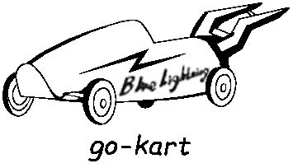
Sally loved cars more than anything else. This spring she thought of building a go-kart to enter for the Go-Go Race. So she asked her dad for help.
“Well,”he said. “How about this:you do some research first and then come back to me with a design.”
A week later, Sally brought her notes and drawings to Dad. She named her go-kart “Blue Lightning”. Dad looked over her work, thinking. “Well, that’s interesting,” he said. “Have a try. Just build Blue Lightning as you’ve designed.”
Over three weekends of hard work, Sally turned her design into a real, working go-kart and painted it light blue. Dad asked her to take it for a test drive. Sally agreed.
After she did that, Sally drove back to Dad.“Well,”she said. “Now I know why you wanted me to have a test drive.”
“Oh, do you?”he said. “Please share.”
“When I drove fast, there was a lot of pushback,”she said. “I think it’s because of the lightning bolt(闪电)shape.”
“Very good!”Dad said.
“So, why didn’t you tell me about that problem in the first place?”Sally asked.
Dad laughed.“Where’s the fun in that?If you give a man a fish, he’ll eat for a day. But if you teach a man to fish, he’ll eat for a lifetime.”
Sally said,“I see. Anyway, designing is half the fun!”
Dad smiled. “Good. Sometimes, learning happens during the process. We learn how to do something right by doing it a few times first and making mistakes along the way.”
That encouraged Sally and she worked even harder. When she showed Dad her new go-kart, he nodded with pride.
Finally came the race. Sally wasn’t worried about whether she would win—in her mind, she had already won, by building something better than ever before.
1.Sally thought of building a go-kart to .
A.practice driving B.enter for a race
C.play with friends D.do some research
2.What did Sally’s dad ask her to do after she built the go-kart?
A.To have a test drive. B.To take a good rest.
C.To give it a cool name. D.To paint it light blue.
3.Sally’s story mainly tells us that .
A.winning a race is important
B.fishing brings us a lot of fun
C.driving experience is necessary
D.learning happens during the process
1.【答案】B
【解析】细节理解题。根据第一段第二句“This spring she thought of building a go-kart to enter for the Go-Go Race.”可知选B。
- 【答案】A
【解析】细节理解题。根据第四段倒数第二句“Dad asked her to take it for a test drive.”可知答案为A。
- 【答案】D
【解析】主旨大意题。倒数第三段中的“Sometimes, learning happens during the process.”为本文的主旨句。故选D。
四
Passage 4(2018北京,A)
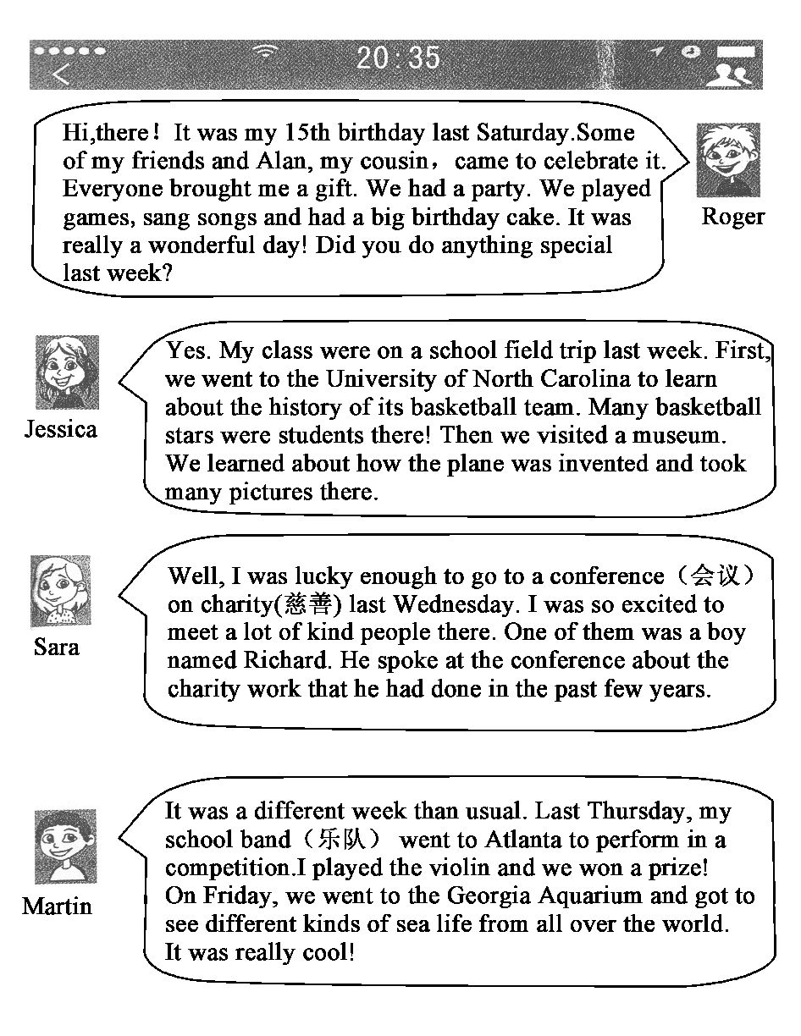
1.When did Roger have his birthday party?
A.Last Wednesday. B.Last Thursday.
C.Last Friday. D.Last Saturday.
2.Who went on a school field trip last week?
A.Alan. B.Jessica. C.Sara. D.Richard.
3.Martin went to Atlanta to .
A.speak at a conference
B.organize a party
C.perform in a competition
D.visit a university
1.【答案】D
【解析】细节理解题。根据Roger说的第二句“It was my 15th birthday last Saturday.”可知答案。
- 【答案】B
【解析】细节理解题。根据Jessica说的第二句“My class were on a school field trip last week.”可知答案。
- 【答案】C
【解析】细节理解题。由Martin说的第二句话“Last Thursday, my...went to Atlanta to perform...”可知答案。

五
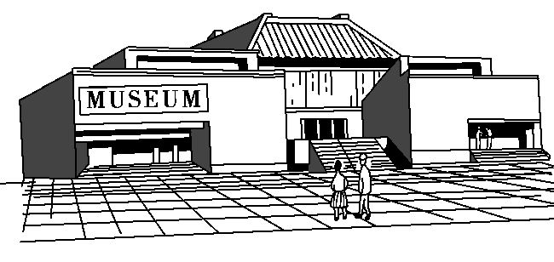
Do you enjoy visiting a museum?Did you ever make a plan before a visit?Every museum must have something that attracts you.And there are many possible ways to enjoy yourself in a museum.
If you follow these steps below,you’ll know what is worth seeing and doing,so that you can make the most of your time at the museum.
Decide what museum you will visit.There are so many different kinds of museums and you first need to find one that you like.It’s easy for you to choose one and start an enjoyable visit!
Do some research online.Every museum now has a website which allows you to look through the information about it.On the website,you may look for such things as:
●The exhibits(展品)—See what is on show at the museum at all times,and what special exhibitions are held for a short time.
●The history of the museum—There will often be very interesting stories about the exhibits and the benefactors(捐赠者).That can make your visit more interesting.
●Activities—See whether there are talks,tours or special activities on the day when you visit.Many museums hold some activities that meet the interests of all age groups.
●Cost,food and storage—It’s important to know how much the visit will cost.You have to decide whether or not you can eat there.You might also need to find out about transportation needs,as well as storage for coats,bags etc.
Learn at least one thing on your visit.It is always good to take away something new from your visit.
Plan breaks into your visit.When you walk around,standing here and studying exhibits there,you may become very tired.So it is important to take breaks.A break is a good opportunity for you to think of what you have seen and what else you might want to do in the museum.
Take a friend or two.Visiting museums is always a lot more fun when you are with someone else.You can talk over what you’re seeing.A friend also brings another way of thinking when you talk about the exhibits.
1.According to the passage,we should first .
A.do some research online
B.make a plan for lunch
C.decide on a museum to visit
D.choose a friend to go with
2.To make our visit more interesting,we can .
A.organize activities like special shows and talks
B.read the stories about exhibits and benefactors
C.learn about the interests of all age groups
D.walk around the museum without breaks
3.If we visit a museum with friends,we can .
A.share the experience with them
B.come up with strange ideas
C.cut down the cost of the visit
D.discuss the next visit plan
1.【答案】C
【解析】细节理解题。由Decide what museum you will visit.可知选C。
- 【答案】B
【解析】细节理解题。根据题干我们把答案锁定在第二个圆点所在的段落。故选B。
- 【答案】A
【解析】细节理解题。根据题干中的关键词“friends”将答案锁定在文章最后一段,再根据本段最后两句话可知选A。
六
In northern Scotland there is a long,deep lake called Loch Ness.More than 200 meters deep,it is the largest lake in the UK.People say a big monster(怪兽)lives in its dark,cold waters.It weighs more than 1,000 kilos and is at least ten meters long.Some people say it has a head like a horse.Others say it looks like a snake.Many people travel to Loch Ness to look for this strange monster,but only a few people have seen it.At least,they say they have seen it.
The Loch Ness Monster is a famous legend(传说).The first story about a monster in Loch Ness was told over 500 years ago,but the legend of the monster spread widely only in the twentieth century.In 1933,a husband and wife reported that they saw a big monster in the middle of the lake.Since then,a number of people have said that they have seen a monster in Loch Ness.Several people have taken photos,but at least one of them was a hoax(骗局).During the 1960s,a team was formed to look for the monster.They took many photos and made movies,but they were never able to find a monster.
There is no real fact that a monster lives in Loch Ness,but there is also no fact that one doesn’t live.One thing is true about Loch Ness:there are a lot of tourists there.
1.In northern there is a long,deep lake called Loch Ness.
A.Scotland B.Hong Kong
C.Rome D.Paris
2.What do people say about the monster in Loch Ness?
A.It weighs about 100 kilos.
B.It is one meter long.
C.It has a tail like a horse.
D.It looks like a snake.
3.When was the first story about the monster told?
A.200 years ago. B.Over 500 years ago.
C.In 1933. D.In 1960.
1.【答案】A
【解析】细节理解题。由文章第一段第一句话In northern Scotland there is a...可知。
- 【答案】D
【解析】细节理解题。由文章第一段第六句话Others say it looks like a snake.可知。
- 【答案】B
【解析】细节理解题。由文章第二段第二句The first story about a monster in Loch Ness was told over 500 years ago...可知。
七
Athletics vs. Gardening
The students of Southside School were asked to give their opinions about whether the school should run an athletic program or start a vegetable garden.
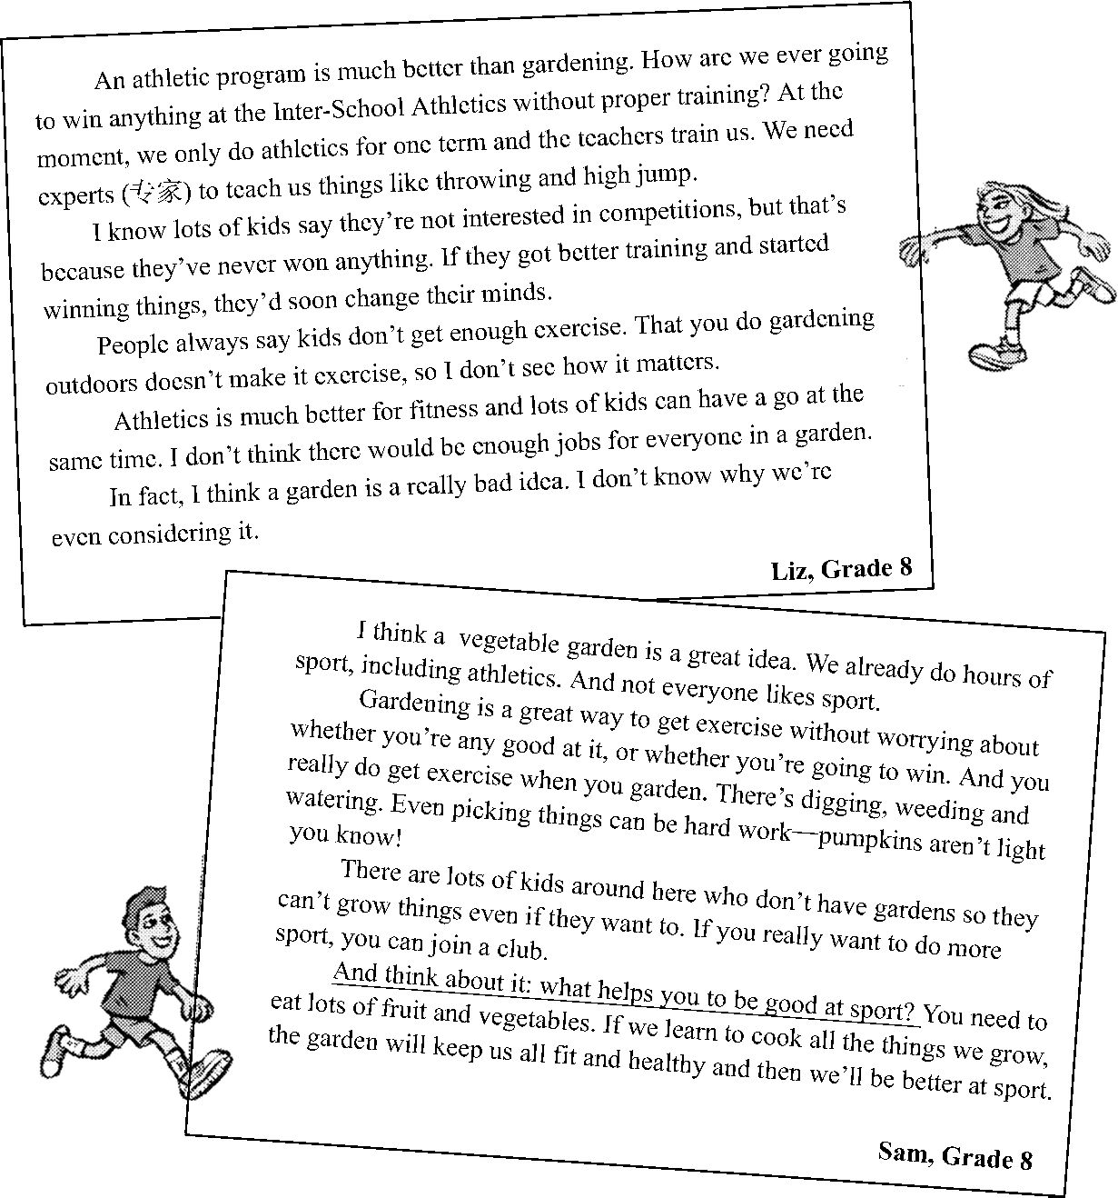
1.Which of these points do Liz and Sam both make?
A.Kids should take exercise.
B.Kids should eat vegetables.
C.Kids should try to win more.
D.Kids should be outside more.
2.What is one reason Liz gives for saying “a garden is a really bad idea”?
A.Some students don’t like getting dirty.
B.Some students don’t enjoy being outside.
C.Some students already know how to garden.
D.Some students may have no chance to garden.
3.Why does Sam say, “And think about it:what helps you to be good at sport?”
A.To change the subject.
B.To introduce his next reason.
C.To support Liz’s idea.
D.To find an answer to the question.
1.【答案】A
【解析】细节理解题。根据Liz的信中第四段第一句Athletics is much better for fitness...可知,Liz非常赞成学生要锻炼;根据Sam的信中第二段第一句 Gardening is a great way to get exercise without worrying about...可知,Sam认为园艺也是一种很好的锻炼方法。由此可见,Sam也赞成学生要锻炼。故选A项。
- 【答案】D
【解析】推理判断题。根据Liz信中第四段第二句I don’t think there would be enough jobs for everyone in a garden.可知,Liz认为不是所有同学在菜园里都有活干,即有些学生可能没机会种菜。故选D项。
- 【答案】B
【解析】推理判断题。根据下文的You need to eat lots of fruit...和...and then we’ll be better at sport可知,Sam说这句话是为了引出他支持种菜的下一个理由。故选B项。
八
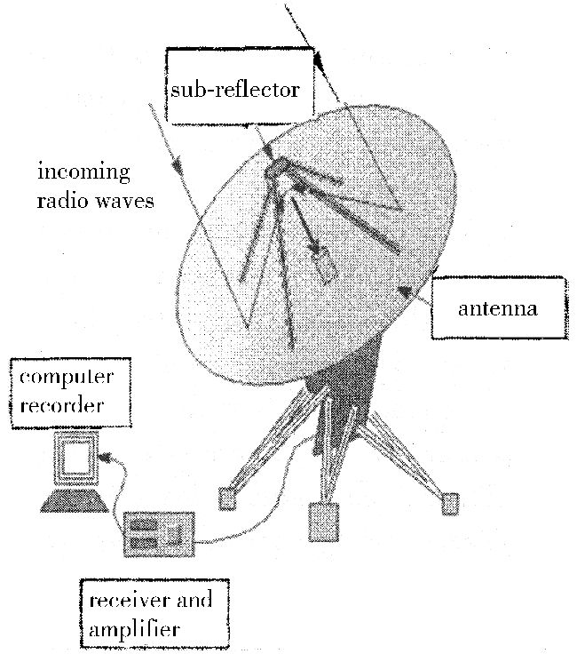
Many objects in the universe are invisible* , but they send radio waves. The radio telescope* thus appeared, and it is considered one of the greatest inventions in the twentieth century. Reber built the world’s first radio telescope in 1937. Ryle and Hewish developed radio telescope systems for the location of weak radio sources, and they shared the Nobel Prize for Physics in 1974.
A radio telescope is usually made up of:
◆One or more antennas to collect the radio waves. Most antennas are made in the shape of a dish to collect and reflect* the radio waves to the sub-reflector, in the same way as a curved mirror focuses visible light to one point.
◆A receiver and amplifier to receive the radio waves from the sub-reflector, and make these weak radio waves strong enough to be recorded and turned into electronic signals*. To make an amplifier sensitive enough, it is usually cooled to very low temperatures (e. g. as low as -270℃).
◆A recorder to keep a record of the electronic signals. Most radio telescopes today keep the signals to the computer’s memory disk for astronomers to analyze later.
Radio wavelengths are much longer than those of visible light, and the radio waves from deep space are always weak. To catch these waves, radio telescopes usually have huge antennas. The sizes of most antennas in use today are around 50 to 300 metres in diameter. The antenna of FAST in Guizhou, China, the latest and largest radio telescope in the world, is 500 metres in diameter, as large as the size of 30 football fields.
To avoid interferences, and keep the telescopes sensitive, radio telescopes are built in places where there are no human radio waves or electronic signals. For example, FAST is 5 kilometres away from the closest village and 25 kilometres away from the nearest town.
Radio telescopes create pictures of the sky, not in visible light, but in radio waves. This is extremely useful, because there are objects that can’t be seen, objects that we wouldn’t even know were there without radio telescopes.
1.Radio telescopes help collect from the universe.
A.light B.objects
C.radio waves D.visible signals
2.Most antennas of radio telescopes are made in the shape of a dish to .
A.make the antennas strong enough
B.increase the number of radio waves
C.turn radio waves into electronic signals
D.focus radio waves on the sub-reflector
3.The underlined word “interferences” in the passage refers to .
A.the noises made by villagers and animals
B.the sounds from the radios and televisions
C.the people who go to Guizhou to watch FAST work
D.the radio waves and electronic signals from humans
1.【答案】C
【解析】细节理解题。根据第一段第一句和第二句Many objects in the universe are invisible, but they send radio waves. The radio telescope thus appeared...可知射电望远镜是用来接收无线电波的。故本题选择C。
- 【答案】D
【解析】细节理解题。根据Most antennas are made in the shape of a dish to collect and reflect the radio waves to the sub-reflector可知“把无线电波集中到副反射器上”正确,故本题选择D。
- 【答案】D
【解析】词义猜测题。由倒数第二段第一句To avoid interferences, and keep the telescopes sensitive, radio telescopes are built in places where there are no human radio waves or electronic signals可知,射电望远镜要避开人类发出的无线电波和电子信号, 故本题选择D。
九
Gardening is popular in many parts of the world. It brings us sweet smelling flowers, fresh fruit and vegetables. But you can get more from your garden.
Gardening helps to keep healthy. Today’s people sit indoors for too long and don’t get much exercise. When you garden, you have to move around. It’s a good chance for you to exercise your body by watering flowers or doing some digging. Besides, when you are in your garden, you can feel the warm sunshine. This means you are getting Vitamin D. It helps your bodies use calcium(钙), which is necessary to keep your bones(骨骼) strong.
1 It gets them off computers, televisions and phones. Gardening can be a great teacher to teach children about nature and healthy eating. It can also help them to understand the meaning of “No pains, no gains.”
Gardening is a great way to meet people and build relationships. When you are gardening, you are outdoors. So it is a perfect time to communicate with your neighbors. Most people love to talk about their hobbies, and so do gardeners. They usually enjoy showing people what they are growing. And most enjoy sharing advice and stories about their gardens.
1.When it’s , you can get Vitamin D in your garden.
A.sunny B.cloudy
C.snowy D.rainy
2.According to the passage, is one of the gardening activities.
A.watching TV B.watering flowers
C.walking dogs D.playing with phones
3.Which of the following can be the missing part in Paragraph 3?
A.Gardening will be good for your bones.
B.Gardening may help people to feel happy.
C.Gardening is a great activity to do with children.
D.Gardening can be a good way to meet neighbors.
1.【答案】A
【解析】细节理解题。根据第二段第五、六句Besides, when you are in your garden, you can feel the warm sunshine. This means you are getting Vitamin D.可知选A。
- 【答案】B
【解析】细节理解题。根据第二段第四句中的It’s a good chance for you to exercise your body by watering flowers可知选B。
- 【答案】C
【解析】推理判断题。通读第三段内容可知,该段讲的是园艺工作对孩子的益处,故选C。
十
Scientists in Britain and the United States have made a new kind of enzyme(酵素) that eats plastics(塑料). With its help, plastics can be turned into smaller parts and go away quickly. Scientists believe that, in the future, it could solve the problem of plastic pollution.
The enzyme is able to break down PET, a form of plastic. PET was first made in the 1940s and is now widely used to make plastic bottles. It can remain in the environment for many years and pollute large areas of land and water. So it has always been a headache to deal with the waste from PET and other plastics.
The researchers made the discovery(发现) while examining the structure of a natural enzyme in Japan. They found that the natural enzyme was helping to break down PET plastics. So, they decided to make small changes to the enzyme by adding some amino acids(氨基酸). It made the natural enzyme’s plastic-eating abilities work faster and better.
John McGeehan, one of the lead researchers, said, “We’ve made an improved enzyme. It’s better than the natural one. And we are trying to make more improvements to it.” He went on, “The enzyme is not harmful to humans or animals, and it is friendly to the environment. So we are considering putting it into wider use.”
The team is now trying to make the enzyme break down PET in large quantities(大量地). “We’ll see that the plastic pollution may be stopped with this technology. However, there is still a long way to go,” John McGeehan added.
1.According to the scientists, the enzyme may solve the problem of pollution.
A.air B.water C.light D.plastic
2.The underlined phrase “break down” in the passage probably means “ ” in Chinese.
A.实验 B.生产 C.发明 D.分解
3.Researchers discovered that a natural enzyme helped eat plastics .
A.in Britain B.in the US
C.in Japan D.in China
1.【答案】D
【解析】细节理解题。根据第一段最后一句中的it could solve the problem of plastic pollution可知选D。
- 【答案】D
【解析】词义猜测题。上文提到这类酵素能解决塑料污染问题,而只有分解塑料才能解决塑料污染问题,故选D。
- 【答案】C
【解析】细节理解题。根据第三段第一句The researchers made the discovery while examining the structure of a natural enzyme in Japan.可知C项正确。
十一
Have you ever imagined going to other countries without your paper passport?That will soon come true. And your paper passport will become history. You may use a new kind of passport called “cloud passport”in the future.
It’s reported that Australia will be the first country to use the cloud passport. With the cloud passport, you don’t have to take a paper passport with you all the time. The cloud passport will have your name, photos and other information. And if you go to other countries, you can just check the information on the computer.
When you take a paper passport with you, you might lose it. But with the cloud passport, you don’t have to worry about that.
Do you think the cloud passport is a great idea?Perhaps you will have it in the future, too.
1.You may use a new kind of passport called“ passport”in the future.
A.cloud B.paper C.history D.photo
2.It’s reported that will be the first country to use the new kind of passport.
A.China B.Australia C.America D.England
3.If you have the cloud passport, .
A.you can take it with you easily
B.you needn’t worry about losing it
C.you can go to Australia freely
D.you needn’t go to other countries
1.【答案】A
【解析】细节理解题。由第一段最后一句可知为“云护照”。
- 【答案】B
【解析】细节理解题。由第二段第一句可知,澳大利亚将会是第一个使用“云护照”的国家。
- 【答案】B
【解析】细节理解题。由第三段可知,有了“云护照”就不必担心丢失护照了。
十二
Bletchley Park
Opening Hours:Every day(Christmas & New Year’s Day)
Weekdays 9:30am—5pm,Weekends 10:30am—5pm
Price:
Adults ￡10 Children(12—16)￡6
Children under 12 Free Tickets bought online 20% off
NRM(National Railway Museum)
Opening Hours:
Weekdays 10:00am—6:00pm
Museum Admission(门票):FREE
Tel:08448 153 139
For big trains,bigger stories and the biggest free day out,come to the world’s largest railway museum. Best of all it’s FREE.
Yew Tree Farm
Add:A3400 Stratford Road
Tel:01564 792 701
Free admission
Opening Hours:TUE—SUN 10am—5pm
A modern shopping village made up of sixteen beautiful houses and a coffee shop in a yard offering all kinds of products from around the world.
1.When can we visit National Railway Museum?
A.On weekdays. B.On Sundays.
C.On Saturdays. D.Every day.
2.Where can we shop and enjoy a cup of coffee?
A.In Bletchley Park.
B.On Yew Tree Farm.
C.At National Railway Museum.
D.On the big trains in NRM.
3.Which of the following is TRUE?
A.Bletchley Park has the longest daily opening hours.
B.We can email Yew Tree Farm for more information.
C.We can visit National Railway Museum at nine thirty.
D.An adult can buy a ticket to Bletchley Park online for ￡8.
1.【答案】A
【解析】细节理解题。从第二则“大英铁路博物馆”中的信息Weekdays 10:00am—6:00pm可知应该选择A项。
- 【答案】B
【解析】细节理解题。只有第三则信息最后一句话中提到a coffee shop,故选B项。
- 【答案】D
【解析】推理判断题。A选项说布莱切利园每天的营业时间最长,但应该是大英铁路博物馆的时间最长,从10:00am到6:00pm;紫杉树农场的介绍中没有提供邮箱地址,所以不能发邮件;大英铁路博物馆的营业时间是从早上十点到下午六点,所以九点半不能参观;由布莱切利园的介绍中的Price中的内容可知D项的说法是正确的,故选D项。

十三
The Sixth Time I Went to the Principal’s Office
When I was in the seventh grade, I had problems behaving. My heart was in the right place, but I couldn’t always follow the rules. I played many tricks on my schoolmates. Once, I even pulled a girl’s hair on the school bus to get her attention. As a result, I was repeatedly sent to the office of the principal(校长). Although I hated going there, I did not hate the principal, Mr. Ratcliff.
Mr. Ratcliff was a kind, elderly man. When he spanked(打屁股)me for putting some ants into a classmate􀆳s pencil box, it didn’t hurt at all, but it did hurt my feelings. I thought so much of him and moments like that seemed to prove I was hopelessly bad.
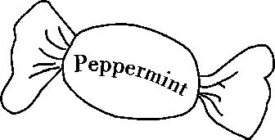
When I got called to Mr. Ratcliff’s office for the sixth time, I had no idea what I had done. I felt disappointed as I walked down there. I went into his office, sat down, and looked at the floor. Then he said the last thing I expected to hear:“Kevin, I’ve heard you’ve been behaving really well lately. I want you to know how proud I am of you, and I just called you down to my office to give you a peppermint.”
“Really?”I was surprised.
“Yes. Now you can take that peppermint and go back to class.”
I carried the peppermint with me as if it was a gold coin. When I got into my classroom, I bragged(吹嘘)to my classmates about my turnaround, excitedly. I wasn’t so bad after all.
Mr. Ratcliff was really kind. He made me realize that I was just a kid who had problems with behavior. He bought some peppermints and took the time to notice me when I got something—anything—right. Mr. Ratcliff gave me some hope by giving me some love. I will just remember him for the rest of my life.
1.In his seventh grade, the writer .
A.hated the principal
B.had problems behaving
C.always followed the rules
D.often helped his classmates
2.How did the writer feel when he went to the principal’s office for the sixth time?
A.Lonely. B.Excited.
C.Confident. D.Disappointed.
3.The sixth time the writer went to the principal’s office, he got .
A.a peppermint B.a model bus
C.a pencil box D.a coin
1.【答案】B
【解析】细节理解题。根据第一段第一句“When I was in the seventh grade, I had problems behaving.”可知正确答案为B。
- 【答案】D
【解析】细节理解题。根据第三段第一句和第二句可知当作者第六次被叫到Ratcliff先生的办公室的时候,作者感到特别沮丧,故正确答案为D。
- 【答案】A
【解析】细节理解题。根据第三段最后一句中的“I just called you down to my office to give you a peppermint”可知,作者得到的是一颗薄荷糖,故正确答案为A。

